SOCIAL MEDIA POSTS
Post this after you register
OR
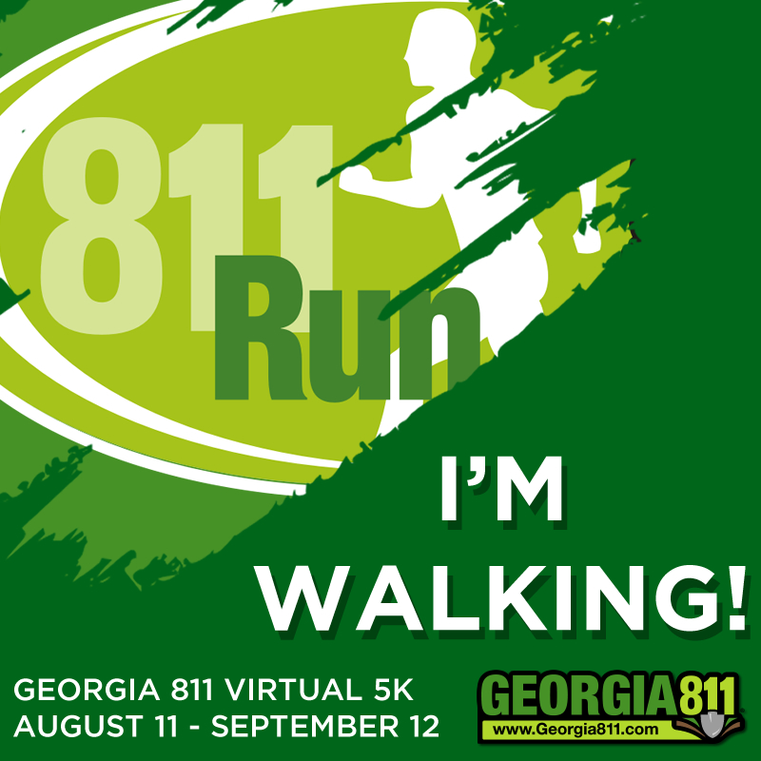
And use this post:
“I just registered to participate in the #Georgia811Virtual5k to help promote Safe Digging. Contact 811 before you dig! Join me and register for Free! https://www.georgia811.com/index.php/811-run-walk/ “

P4 Foundation Participants may want to use this wording:
“I just registered to participate in the #Georgia811Virtual5k to help promote Safe Digging. Contact 811 before you dig! You can register for FREE and any proceeds from purchased shirts benefit the P4 Foundation! https://www.georgia811.com/index.php/811-run-walk/ “
Post this when you have completed your 5k (Or post a selfie on social media after you walk holding your virtual bib or wearing your 5k shirt if you have them.) Don’t forget to tag @GA811 on Facebook or Twitter and @Georgia 811 5k Run & Walk on Facebook

“I just completed the #Georgia811Virtual5k. You can participate for free between August 11 and September 12. Practice safe digging and Contact 811 Before You Dig! https://www.georgia811.com/index.php/811-run-walk/ “

