Ticket Actions on the Portal

Search Tickets (Before Login)
The Search Tickets menu allows excavators to do a search with a ticket number.
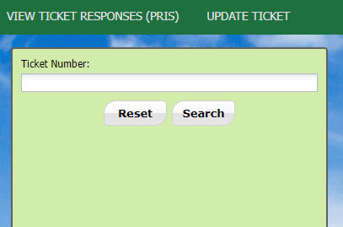

Update Tickets (Before Login)
The Update Ticket menu allows excavators to update tickets with the ticket number, the phone number or email address associated with the ticket.

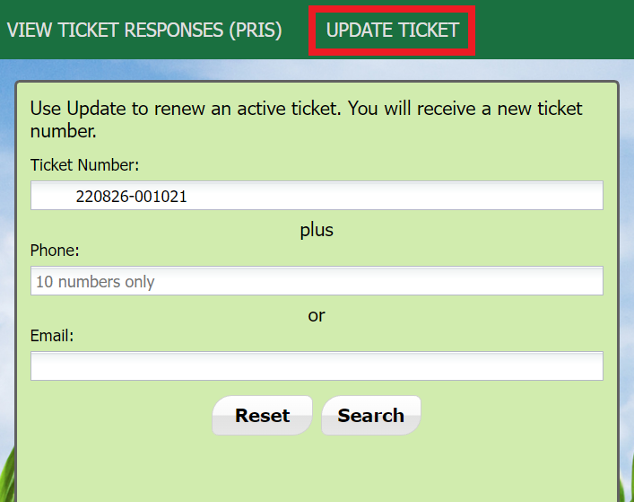

Search Tickets (After Login)
The Search Tickets menu allows excavators to do more complex searches with or without a ticket number.
At the top menu bar of the ticketing system, click on “Search Tickets” to open the ticket search menu.
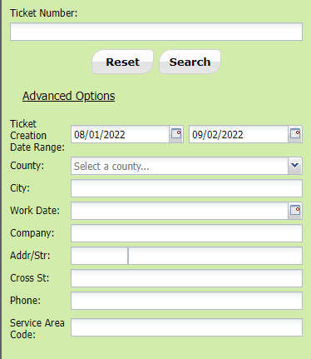

Back (After Login)
Back will go to the previous screen.

Print (After Login)
Print will allow you to print a copy of the ticket.

Show Map (After Login)
Show Map will show the map that has been saved for the ticket.

View Log (After Login)
View Log will show how many times the ticket has been opened and by whom.

History (After Login)
The History will show a list of activity of the ticket.

Send to Me (After Login)
Send to Me will allow a copy of the ticket to go to the email listed in the body of the ticket.

Send to Email (After Login)
Send an email copy of the ticket with this option.

Update a Ticket (After Login)
An Update extends the life of an existing Normal ticket. A new ticket will be generated. The ticket lets the utility members know that the digging is ongoing and to check their markings. The Utility members must respond to the Ticket Response System (PRIS) and markings will be remarked if necessary.

Cancel a Ticket (After Login)
The Cancel Ticket feature allows you to cancel an existing ticket. Cancelling a ticket will also disable the following ticket actions on all associated active tickets within the web portal: Additional Request, Update, Cancel.

Additional Request (After Login)
An Additional Request is sent to re-notify the utility members on an active ticket.

Copy (After Login)
Copy a Ticket A Copy allows you to replicate an existing ticket through the Online Ticketing System. This feature will allow you to replicate all fields of an existing ticket including the dig site map, and change or update fields before submitting. A new ticket will be created, and you will receive new legal dates and times.

